1. **Till now we have seen a lot of possible operations that we can do with the Stub**
   1. Create, Delete, Update, Retrieve for stubs.
   2. How to proxy: Useful in MS Model App.
   3. Processing of recording: Instead of us to create stub, the recorder creates stubs.
   4. How to retrieve response from external file using “**bodyFileName**”.
2. **Agenda:**
   1. **Let’s see how to automate stubbing.**
3. **Let’s configure WireMock and Test using Java**
4. **Adding Dependency:**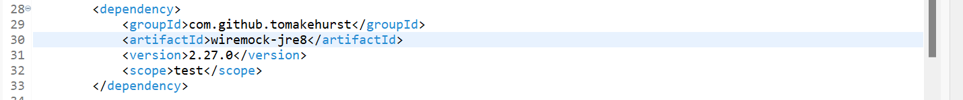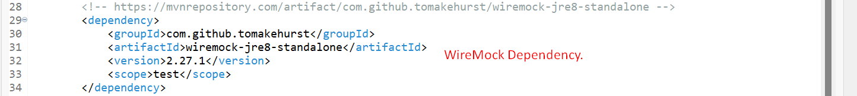
5. **We will do testing using RestAssured:**  
   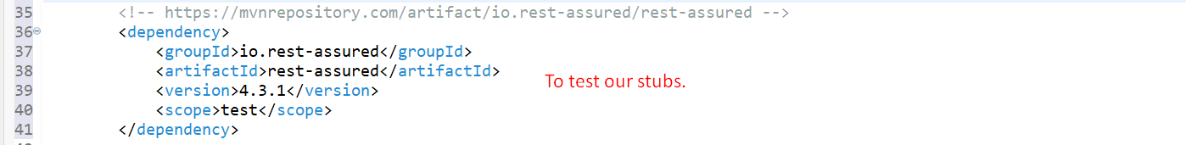
6. **Junit 4 Dependency:**